DRAFT DATED 9TH sEPT 2014

2012 – 2015 Triennium Work Report
Chapter: Drivers and Business Models
June 2015

Programme Committee D3: SMALL SCALE LNG
Chair: Wouter Meiring

Table of Contents
Introduction 3
Key drivers for small scale LNG 4
Small Scale LNG comes into play in three main scenarios: 4
Drivers for LNG Producing Projects 4
Small scale LNG vessels 7
Drivers of Small Scale LNG Transport 7
Drivers for LNG consuming projects 10
Small scale re-gasification terminals 11
Sourcing of LNG for small scale LNG terminals 11
Business Model for LNG producing projects: 11
Business model for LNG consuming projects 16
Conclusions 17

Introduction

Growing awareness about natural gas that offers an affordable and environmentally acceptable solution to power human being across the globe is making the natural gas the most sought after fuel. Liquefaction of natural gas at -161⁰C (-260⁰F) shrinks the volume of the gas 600 times, making it convenient to store and ship across the globe. Thus, LNG is increasingly becoming the preferred delivery method because LNG can be produced at remote locations and distributed to end-users conveniently. Driven by growing global natural gas reserves, advancement in technology to monetize natural gas from marginal / stranded fields, favorable gas prices, and stricter emission regulations; LNG is being preferred to substitute traditional oil-based fuels in marine or heavy vehicle engines, power generation and process industries. This is leading to emergence of small-scale market that calls for decentralized LNG plants and distribution facilities. Therefore, small scale LNG is now growing beyond a niche market.

Small Scale LNG (SSLNG) is catching attention of all stake holders across value chain such as LNG producers, exporting Terminal operators, Shipping Companies, Receiving Terminal Operators, Distributors to end customers, etc. Every stake holder across the value chain is playing its role to facilitate development of small scale LNG on sustainable basis. In order to illustrate, facilitators may be sub-divided into two categories namely – facilitators for producers and facilitators for consumers. The production and consumption of LNG on a small scale has historically been limited to a few countries. However, new environmental emissions policies and diverging oil and gas prices have led many regions to begin building up small-scale infrastructure. In the past, small-scale LNG was mainly traded in a manner similar to its large scale counterpart, and consumed within the power and industrial sectors. As the technology and feasibility have improved, the SSLNG business has rapidly expanded. New players are entering the market, while existing players are expanding. Many new regions have turned to small-scale liquefaction and retail LNG in order to cut emissions or fuel costs. Small-scale liquefaction and re-gasification facilities are defined as plants with a capacity up to 1 MTPA; SSLNG ships are defined as vessels with a capacity of under 18,000 cbm.

Key drivers for small scale LNG

Key derivers for such developments are economics, technology & environmental concerns leading to Government interventions through Policies or Regulations.

- Economics: Fuel cost advantage of LNG over alternate liquid fuels. LNG is a cheaper and less polluting fuel, which has significant emission related advantages over fuel products.

- Technology: Liquefaction technology and LNG engine technology for ships and trucks are available

- Environmental: Air emission advantages: No SOx, no particle, low NOx

- LNG fuel meets stringent emission regulations, like MARPOL imposes strict NOx and SOx emission limitations for ships in ECAs “Emission Controlled Areas”(e.g. North & Baltic Sea) from 2015

Small Scale LNG comes into play in three main scenarios:
- Brings gas where there is no Pipeline gas access - Stranded customers – too small or too far away from pipelines and currently using other fuels like LPG, Propane, Naphtha, Diesel and fuel oil.

- Gas where it is needed sooner than later - Developing countries - where speed of getting energy supply will impact economic growth and low capital cost infrastructre is needed for launching projects.

- LNG’s liquid state enables it to offer a more environment friendly alternative for traditional fuels which can be used as a transport fuel in the transport sector, for heavy duty trucks and for the marine sector.

Drivers for LNG Producing Projects

Moving to an energy economy based on gas as a means of generating power is very important and a key for the most countries and LNG represents the most flexible means by which a country, not having control of local gas reserves, can access import supplies from the global gas market. As such, The SSLNG has been traditionally considered an important business in North America, Asia and Europe (specifically in the Scandinavian and Baltic Region).

Small-scale liquefaction plants are built with variety of objectives in mind, including commercializing small gas fields, shortening gas-to-market times, marketing small quantities of gas usually flared, peak shaving and direct use of LNG. While many companies are developing stand-alone small-scale units, others have proposed building ‘large scale’ projects with multiple small modular liquefaction units. The developers of most small-scale projects turn to small-scale liquefaction either because their targeted gas reserves are not large enough to support a bigger project, or because they hope to take advantage of cost and time efficiencies from less infrastructure and a more modular design. Smaller plants are estimated to have a shorter construction time and a much shorter design and engineering schedule, particularly if they target pipeline gas as feedstock rather than a small gas field, allowing more rapid responses to demand surges. For example, the 0.3 MTPA Skangass LNG facility was completed in around 3 years, compared to 4-5 years for a large scale facility.

Further, CAPEX requirements are obviously on average significantly lower, but on a $/tonne basis they are not necessarily more competitive than their large scale counterparts. Small-scale plants lack any benefits that economies of scale give to larger projects, but due to their minimal size and relative simplicity, there is a lower need for on-site infrastructure (such as independent power generation) and specialized equipment.

SSLNG units are also often used as peak shavers to help meet demand. These facilities contain both liquefaction and re-gasification abilities to more compactly store gas until times of peak demand, when the LNG can be quickly re-gasified for use in retail applications, such as power generation or residential consumption.

To date, only a few major LNG suppliers have expressed an interest in supporting SSLNG markets, where large players have been motivated by the need to expand their marketing portfolios to reach new markets and countries where LNG is not reachable such as Sweden, Finland, Iceland, and Denmark, Where the optimal way for those countries to receive gas and LNG is by building small re-gasification terminals where they can be built faster and are low in operation and capital costs.

In general, the drivers for SSLNG are almost identical to the drivers of Large Scales LNG projects. The first step is ‘know your customer’, where it is very important to understand who the buyer of the LNG is and where the LNG is going. SSLNG has attracted few of the big players in the market such as Gazprom, EdFT and Shell. LNG producers are more concerned with securing the right price for the LNG (i.e. producers need to cover their costs by securing pricing netbacks) and this could be a challenge. In order to be attracted to SSLNG buyers, LNG producers need to find enough creditworthy customers to be able to finance the project while optimizing their equity return.

The other point that is very important for the producers is where the LNG is going to (which market). It is very important to understand that LNG is the main source of energy or the driver in that specific market due to established environmental regulations. Is LNG the next best alternative for that market or is it a different source of energy (i.e. coal, nuclear)? Governments are demanding fewer toxic and greenhouse gas emissions from power plants, ships and trucks. For instance, in European Union, if the LNG is to be used in heavy duty vehicles/trucks, then it will be subject to the European emissions standards. Compliance with these standards using diesel engines will require costly emissions treatment and a potential increase in operational and capital costs, therefore, natural gas is the best solution (LNG is the preferred form due to effective fuel density).

The construction of liquefaction units for the purpose of providing LNG as a fuel for transportation is a more recent phenomenon that has gained fast ground in China and US, though has proliferated around the globe. Both countries have a sizeable LNG in trucking industry; China in particular has rapidly built up its domestic liquefaction infrastructure to replace diesel and cut vehicle emissions.

Another example would be to use LNG in marine transportation, which is the biggest demand and driver for potential SSLNG facilities within the Scandinavian and Baltic region. In order to do so, vessel owners and charterers will have to comply with Sulphur Emission Control Area. With all these outlined characteristics and drivers for SSLNG facilities, producers will be more incentivized to have a significant recognition for providing lower emissions alternatives to Europe

Small scale LNG vessels

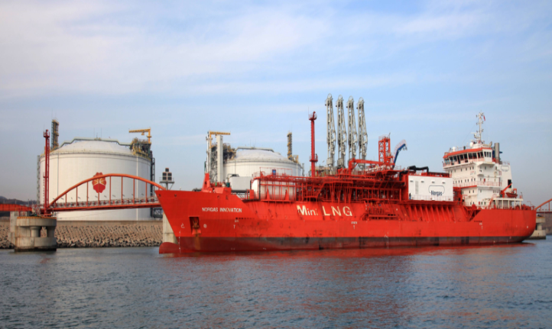
Small scale LNG vessels play significant role in small scale LNG growth. Now a days, small scale LNG vessels are intelligently designed to be able to load from the Large scale conventional LNG terminals and then discharge at small scale LNG terminals. Thus they can be utilised to supply LNG to small islands, and remote powerplants as well as factories and mining sites.
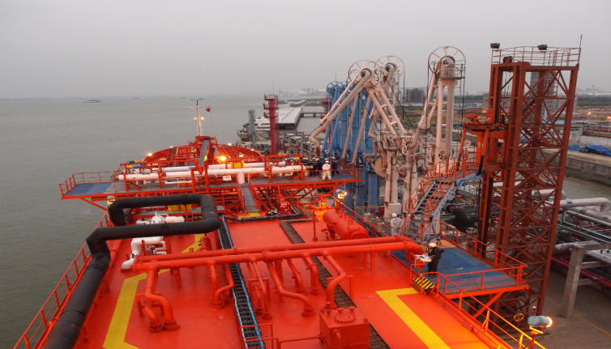

Figure 2: Small LNG vessel Norgas Innovation discharging at small sale LNG terminal at Jovo (Source:I M SKAUGEN)
Figure 1: Small LNG vessel Norgas Innovation loading at Dalian LNG terminal (Source:I M SKAUGEN)

Drivers of Small Scale LNG Transport

There are primarily following three key drivers for growth in Small Scale LNG Transport:
- Increase in LNG supply & demand and related infrastructure
- Gas & Oil price spread
- Environment

The first two drivers i.e. LNG supply & demand and the Price of LNG in comparison to other fuels are interlinked. With the shale gas boom in U.S., Canada and other parts of the world, the LNG prices have been attractive while the availability of LNG is increasing. If we compare the Heavy fuel Oil and LNG prices in Asia, the Price of Heavy Fuel has almost doubled in last three years whereas the price of LNG has more or less remained the same. In Europe the LNG prices are much lower than all other marine fuels including HFO. In USA due to the shale gas boom the LNG prices have fallen down to a level almost half of the HFO price. In the below diagram the forecasted price movements of different marine fuels have been provided, which demonstrates the definite price advantage for LNG as a fuel. The LNG price below is average LNG equivalent hub price for large scale LNG; there would be a small premium when using this LNG price for small scale LNG.

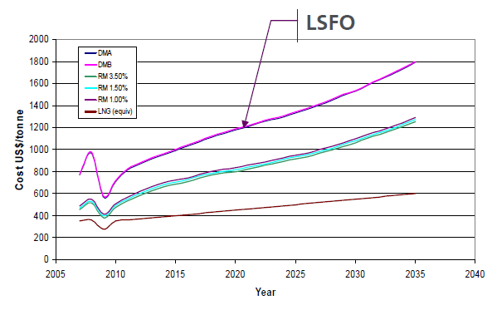
LSMGO
Figure 3: Forecast of development of prices for Marine Fuel (Source: Lloyds)

The third driver of SSLNG is the environmental policies. The new environmental regulations requiring reduction in Sulphur Oxide ( SOx) and Nitrogen Oxide (NOx) emissions from vessels are pushing demand of SSLNG in LNG bunkering of ships.
International Maritime Organization (IMO) is an agency of the United Nations Organization which has been formed to promote global maritime safety. Under the IMO, MARPOL Annex VI, strict rules have been laid out with regards to the SOx and NOx emissions by vessels worldwide. Two sets of emission and fuel quality requirements are defined by Annex VI:
(1) Global requirements, and
(2) More stringent requirements applicable to ships in Emission Control Areas (ECA).

Existing Emission Control Areas include:
- Baltic Sea (SOx )
- North Sea (SOx )
- North American ECA, including most of US and Canadian coast (NOx & SOx).

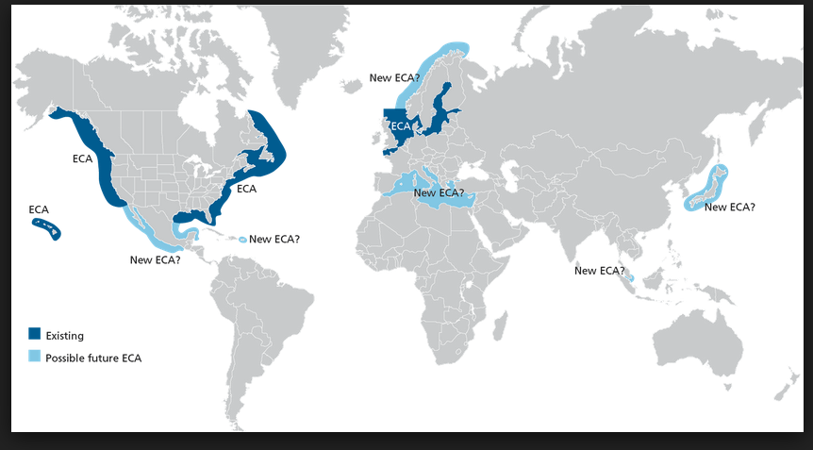
Figure 4: Overview of Current and Possible Future ECA (Source: DNV-Greener Shipping in North America)

The graph shown below demonstrates the restrictions on Sulphur content in marine fuel. The requirements coming into force in 2020 are subjected to a review of the refinery capacities and availability of suitable fuel in 2018.
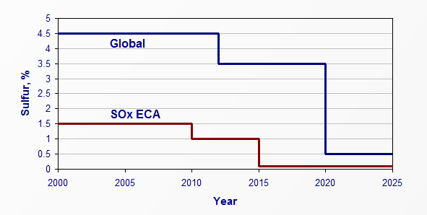
Figure 5: MARPOL Annexe VI regulation on Sulphur requirements in Marine Fuel (Source: http://www.dieselnet.com/standards)

Similar restrictions have been placed on the emission of Nitrogen Oxide gases (NOx) from vessels engines. NOx emission limits are set for diesel engines larger than 130 KW, and are dependent on the engine’s maximum operating speed.These regulations are imposed by International Maritime Organization (IMO) through the revised MARPOL Annex VI, 2008.

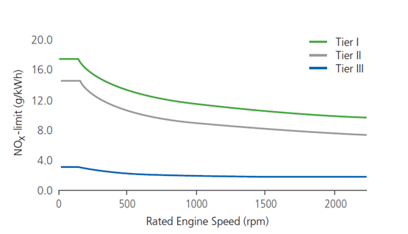
The limits of emission of NOx are tier based, and are related to year of construction of the engine and area where the vessel operates. Tier I and Tier II are global requirements while Tier III is applicable to ECA areas. Tier III requirements were scheduled to come into force from 1st January 2016, however committee of the IMO voted in May 2013, to postpone the entry into force of the MARPOL Annex VI Tier III NOx emissions limits for ship engines from 2016 to 2021.
Figure 6: NOx regulations

Apart from above requirements, Annex VI also has requirements for Green House Gases (GHG) emissions and release of Particulate Matter (PM). Using LNG as a bunker fuel in marine solution provides a single and effective solution to all above requirements. LNG fuel has the lowest emission of all three local pollutants NOx, SOx, and particles, as well as the global greenhouse gas CO2. Using LNG as bunkers, NOx emissions are reduced by 85–90%, SOx and particles by close to 100%, and net GHG emissions by 15–20% (Source: DNV). The reduction in GHG emissions would be dependent on the Methane emissions, which may reduce the savings in emissions to zero % especially for two- stroke engines.

Drivers for LNG consuming projects

Liquefied natural gas (LNG) boasts a number of advantages, which are driving its growth. It combines the clean combustion and higher calorific value of natural gas with the transportation flexibility in various form of natural gas. LNG should have an increasing role as transport fuel considering its environmental benefits. There is general consensus that use of dedicated Natural Gas Vehicles (NGVs) results in 20% to 25% less CO2 emissions compared to petroleum fuels, thus contributing to cleaner and healthier ambient air. This is especially welcome for urban areas, making natural gas ideal for community fleet vehicles like buses or refuse collection trucks. More and more passenger vehicles, moreover, are running on natural gas.

Small scale re-gasification terminals

The majorities of small independent re-gasification terminals are used to import globally-produced LNG, and are located in areas with limited demand or size constraints. For example, Japan holds the most existing small-scale import terminals, many of which were built as satellite plants or units near larger, older terminals, though some can attribute their small size to space constraints or lower demand.

Advantages of small-scale import terminals are primarily lower cost, speed of construction, and added flexibility. Indonesia has proposed building nearly a dozen “mini” LNG terminals in order to service islands with no gas pipeline infrastructure; the plants would all be supplied by domestic LNG produced at Bontang LNG.

Multiple European countries have proposed building small-scale import terminals, spurred by EU subsidies for developing LNG that could be as large as 10-20% of the terminal development cost.

Sourcing of LNG for small scale LNG terminals

There are several different LNG sourcing strategies among small-scale terminals. Some, like the Fredrikstad terminal in Sweden, are supplied by regional small-scale liquefaction plant i.e. Skangass LNG in Norway. In Japan and China, some small-scale terminals are supplied by traditional large scale liquefaction plants, such as Malaysia LNG and Bontang, using SSLNG carriers. A third set of terminals receive LNG that has been produced by large scale international plants, but is first delivered to larger import plants and then transferred by small shuttle vessels or onshore trucks. Several of the Japanese terminals operate in this way, while Chile has a small onshore regasification facility located near a refinery in Pemuco, to which it transports LNG from the large scale Quintero regasification plant on the coast.

Business Model for LNG producing projects:

In terms of source of supply, we can distinguish into two main categories of projects:
1) Related to E&P gas resources’ monetization:

- Special purpose projects for small size gas resources that would be stranded by conventional gas pipeline/LNG means. That means that the small scale liquefaction project is the main (and probably only) monetization way for the gas resources.

- As a “by-project”, a second monetization option out of a main monetization option. For instance: a small LNG project for regional markets on top of a main conventional LNG project for export.

In both cases, apart from the E&P producing facilities, it is required a contractual assignment of the gas resources to the LNG project; for case 1a) it’s a straight forward way as for the conventional LNG projects, for case 1b) the small scale project can potentially benefit of marginal E&P costs.

2) Not necessarily related to E&P gas resources’ monetization:

- Break-bulk projects: this kind of projects receive conventional LNG (conventional in terms of size of LNG carriers, and receiving facilities) and provide LNG distribution, for small scale consumers making use of small scale logistics and receiving terminals.
These projects, in terms of supply require a LNG SPA with conventional LNG providers (it can be on long term/spot basis)

- Satellite plants: this kind of projects, make use of a trucks logistics for achieving typically remote and small gas consumptions (that have small scale regas capacity). The source of supply can be both LNG from a conventional receiving facility or small scale liquefaction from a source of gas (i.e. gas pipeline).
These projects, in terms of supply, require having SPA contracts (long/short term) for the gas or LNG they use as a source of supply; if conceived as a secondary business from a conventional LNG receiving facility, they require to set the terms&conditions for making use of the conventional facility.

- Peak shaving plants: these projects put in place small scale liquefaction facilities for taking gas from a conventional source (typically a gas pipeline) store it in small scale storage as to be able to regasify the stored volumes for peak demand seasons. Also, this kind of projects has a commercial driver (storing gas when gas prices are lower for regasifying when gas prices are higher).
These projects, in terms of supply, require having access to a gas SPA; typically these projects make use of a portion of such SPA.

In terms of producing facilities:

Modular model for LNG has been developed especially for the emerging small scale LNG market with the objective to offer a plant with lowest CAPEX and shortest execution time ideally targeting the specific needs of small-scale LNG distribution chains. The great benefit of small-scale LNG applications is the rapid response time between idea sharing and turn-key plant delivery.

As for the conventional LNG projects, there are “classical” approaches:
- Integrated business model/merchant: the company who develops the gas supply, holds all the required facilities for production and commercializes to the final destinations. If there are more than one partner, a Joint Use Agreement over the facility is required.

- Tolling: a third party makes the investment and operates the producing facilities in exchange of a tolling fee for processing the gas. The company who markets the gas doesn’t have the property of the facilities. This requires among others, a Tolling agreement.

In the case of small scale floating projects related to E&P gas resources’ monetization, the tolling business model is often taken by the developers.

For this small scale liquefaction projects, there are specific technology providers out of the conventional ones, with specific and patented processes conceived for this size of projects. It is required to obtain licenses from these technology providers.

For the cases of small scale projects which are by-projects with respect to another conventional facility (such as break-bulk or production for satellite plants) it is required to have contracts that regulate the terms & conditions for making use of the services provided by the “main project” as well as the operations. In addition, in some cases, such as the break-bulk projects, it is required dedicated facilities that need to be integrated (for example, a dedicated jetty/offloading facilities).

For the transportation of the produced LNG, the logistics business model depends on several interconnected factors: storage capacity, distance to targeted markets and size of the consumers, as for the conventional LNG projects. Of course a key factor is the positioning and number of customers (access to port facilities / inland customers).

As for conventional LNG projects, the LNG sales can be done on FOB basis (at the exit flange of the LNG producing facilities; transportation to be arranged by the buyer) or DES basis (sales at the inlet flange of customers receiving facilities)

Notwithstanding, for the small scale projects there can be some particularities:

- If conceived for “regional” marketing (by the sea), the SS LNG project can make use of small size LNG carriers (typically 10.000 to 30.000 m3) that make sense for this distances and for small scale LNG consumers. The logistics is very linked to the final market size. For this case, the SS LNG carrier’s fleet would probably be dedicated, at least while the markets are building up. In any case it’s likely that the tendency is to time charter the carriers to a ship owner.

- If conceived for exporting to long distance international markets, the storage capacity for the project needs to adjust to the conventional LNG carriers capacity; then, as an small scale production, the number of cargoes to be transported would not be that big (low frequency of cargoes) , therefore the business model for shipping can both be done by dedicated fleet (maybe not fully optimized, except if for a portfolio player) or with spot carriers capacity. Again, it’s likely that the tendency is for time chartering the fleet. It’s also likely that the shipping is in charge of buyers (FOB LNG sales)

- For the projects with marine logistics, the “milk run” approach is an option but needs to be well tested case by case as the risk of having un-optimized fleet (and its related expenses) is not negligible.

- If conceived for trucks logistics (for supplying peak shaving, satellite or inland small scale consumers) the trucks fleet needs to be carefully optimized , taking into account: trucks capacity vs number of trucks; number of customers and offloads frequency, ability for partial offloads (milkrun).
The target markets (and specific customers) for the SS LNG producing projects, as for any LNG producing project, is a key element for the business model for several reasons:
- Logistics (addressed in the transportation section above)
- Forecasted demand and price signals
- Reliability of the markets and customers.

- Markets reliability in terms of expected sustained need of supply, and sustained conditions of the market.

- Customers: as typically the consumers will have a small consumption, it’s important that the companies who will be buying the LNG have enough balance sheet strength as to enter in long term commitments.

Other parameters to take into account for the business model:

- Financing: on one hand, these projects are, as smaller than the conventional ones, are less capex demanding; on the other hand, the companies who want to develop this kind of projects need to have a balance sheet that allows them to enter into the required long term commitments and therefore to be able to attract financing in good conditions.

- Fiscal regime: in some cases, as the small LNG projects can help to develop natural gas consumption both as a bridge supply or to feed remote areas non connected to the main transportation grids, the local authorities can provide this projects with

- Policy and regulations: mainly for markets not developed, this can be an issue when addressing a new SS LNG project. In case of an export SS LNG project in a country without previous experience in LNG, the lack of specific gas export regulation will be an issue to be solved; the developers must show to the authorities the potential value for the country (apart that for the project itself) if they want to expedite the process.

Business model for LNG consuming projects

Market and customers
Market for small scale LNG is expanding. Small scale carriers, such as LNG heavy trucking or LNG small vessels can allow access to LNG to remote market, scattered islands, or the area that has the limited access to gas via regional pipeline gas infrastructure, including industrial estate, large truck fleets, as well as residential consumers.

Power and Industrial sectors

Business model for distributing LNG to the retail market can be through tanker trucks to one final industrial consumer or to several LNG satellite plants. In those plants the LNG is stored and re-gasified in order to be injected to a gas distribution network for industrial and domestic use. Satellite plants have the essential basic systems such as unloading unit (for LNG tanker trucks), LNG storage & its re-gasification, measurement and send out. This investment can be financed by either the retailer or industrial end users considering the contract and pricing arrangement. In the case of US, increase in gas supply has played a key role in increasing the market penetration of LNG for small industrial users. Several oil and gas companies in the US and Canada have proposed plans to install LNG capabilities at production sites to fuel drilling rigs and hydraulic fracturing units. Almost 20 industrial customers in India have set up small LNG storage and re-gasification facilities and have been sourcing LNG from existing large LNG Terminals through road tankers. Japan runs some small-scale distribution projects from its numerous LNG receiving terminal, mainly utilizing dedicated small scale LNG vessels. The small volumes of LNG are used in power stations as well as residential and industrial consumers.

Use of LNG as fuel in road transportation

The use of LNG in road transportation has increased most rapidly in the US West Coast, Europe and China. The growth of LNG truck markets depends on the price differential between LNG and other alternative fuels like gasoline or diesel. Higher oil prices are required to make a profitable switch to LNG as fuel in road transportation. The key success factors of promoting the LNG consumption in road transportation are LNG refueling stations and the development of technology enabling use of LNG as fuel in cooperation with established automotive manufacturers.

In the US, refueling stations are concentrated mainly in the west coast due to its more aggressive emission standards. Throughout the rest of the country, the onshore LNG transportation industry is also expanding. Replacing diesel with LNG can provide significant cost savings for heavy-duty truck fleet operators, including some city buses and regional buses, and garbage truck operators. In China, more than 400 refueling stations are in place at the end of 2012 and LNG powered trucks accounted for 7 % of all heavy duty vehicle sales in 2013. Chinese government is investing heavily in building the required infrastructure for heavy LNG vehicles. Public bus fleets have also been converted from diesel to LNG in some cities in China.

European markets currently have some LNG fuelling infrastructure. The European Union (EU) has commissioned a study under the name of ‘LNG Blue Corridors’ to identify possible roadmaps for adoption of LNG in heavy transport. Under this study, LNG fuelling stations will be built and fleets of LNG heavy vehicles will be set up to study the LNG market development for road transport.

Marine Transportation

Strict government policies and targets for reducing emissions as mentioned above in this chapter have made small scale LNG an increasingly attractive option for the short sea shipping sector. The business model for marine transport starts as a small scale LNG tankers deliver to refueling stations, lightering vessels or storage hubs. Then, bunkering barges deliver fuel to end-user via ship-to-ship bunkering or refueling at port. End-user refuels at ports of call or via ship-to-ship bunkering at sea.

Conclusions

Thus it can be concluded that the small scale LNG business is poised for robust growth in the near future and is tightly linked to the growth of LNG demand. Today, LNG is a mature technology chain, offering significant economic and environmental benefits; hence small-scale LNG is a very promising new business model for tomorrow’s markets.

SSLNG is growing across the globe and is expected to go a long distance. The industry is very dynamic in North America, driven by increased gas availability from shale gas production, as well as economic factors such as the substantial price differentials between gas and oil products. The economic and environmental advantages of using LNG as fuel will drive growth in China, to fight pollution in urban areas, while stricter regulations on the marine sector will boost the use of LNG in Europe.

As the growth of the SSLNG business is intrinsically linked to the LNG availability, its deliverability and sustainable demand of LNG, this creates a potential stalemate where consumers wish for security of supply before committing to LNG, while potential suppliers need to secure a market to justify the investment. The unlocking of such a dilemma is being addressed in different ways in different parts of the world. Regional factors such as the lack of pipeline infrastructure and increasing emission regulations strongly support the growth of SSLNG.

The main challenges for SSLNG lie in the development of a consistent normative and regulatory framework, including safety standards for the handling of SSLNG and investments to provide the infrastructure to support a wider distribution without jeopardizing cost effectiveness. However, implementation of this value chain will introduce new challenges, for example in the area of BOG management and meeting fuel quality requirements to use LNG as fuel. Still, no technical bottlenecks hinder the growth of this sector. Moreover, improvements to project economics are expected from standardization and modularization for production facilities.

Reference for Business Model for LNG consumption projects:
IGU World LNG Report – 2014 Edition
LNG Bunkering Opportunities, PACE Global, Feb 2013
The Evolution of Small-Scale LNG Markets, Gazprom Export, Small-Scale LNG Forum
22-23 October 2012, Istanbul
Small Scale LNG: need for new business models? , www.enerdata.net
Website of I M Skaugen for small scale vessels

